E- PHARMACY DEVELOPMENT SYSTEM
ABSTRACT
Over the last decade, the issue of internet medication has plagued pharmacies and the broader healthcare community. Alternative choices for persons seeking medicine, with or without a prescription, are available on the Internet, and numerous experts have outlined the dangers and advantages. While counterfeit medicine and the increased usage of internet drug information are strongly related to this issue, these articles are outside the subject of this work. Different opinions concerning customer motivation and knowledge while buying drugs online are revealed in this discussion. Misconceptions concerning online prescriptions are surfacing, such as the purchase of over-the-counter drugs and the lack of product information. Despite indications that some illegal drug purchases are made online, research suggests that shops, family/friends, and legal prescriptions are the most common sources of conversion. An online pharmacy can evaluate its potential to provide mental treatments alongside pharmaceuticals, which has a future in drug delivery. To avoid losing the new ‘strings' generation of future parents and caretakers, brickand-mortar pharmacies should reflect the value they provide to their profession.
The main aim of developing this application is to provide all the medical related solutions through a single application. E-Pharma is a platform where patients and doctors can interact directly. Patients can self-diagnose from the direct doctor-patient relations, consumer experience in online purchases, the ease of mail-order trade and distance selling. The patient can consult with the doctor and can also order medicines which were prescribed by their doctors with just one click. Patients can also get information about the laboratories and medical shops present in their area.
1. INTRODUCTION
1.1 ABOUT THE PROJECT:
The demand for medical and medical services outstripped the fluctuating ocean currents as COVID19 travelled throughout the globe. On the one hand, the globe was in desperate need of COVID-related health infrastructure, but demand for common services and medications was declining. Consumers and individuals throughout India are resorting to online delivery for practically every necessity, including groceries and gadgets, due to the closure and possibility of COVID19 infection.
We may give an Internet Forum as part of our programmed to interact with persons who operate pharmacy management or merchants. We can supply a web application utilized by physicians or any hospital personnel in this programmed, and we have established a single quotation for user and customer, so we can place our product in our system, and the buyer may buy it, as well as order or submit a quote to our system. Testing and interpretation of medical prescriptions, medication administration, prescription drug withdrawals from certified physicians, prescription drug reviews, and appropriate drug preservation are all part of pharmacy profession. The American Pharmacists Association defines pharmacy as a role responsible for assuring correct and appropriate medication usage, as well as the utilization of pharmacological resources in order to produce improved medical results, including birth control. Some argue that the rise in global life expectancy from 45 to 50 years is due to the number of triumphs documented in pharmacies during the last century.
SYSTEM STUDY
2.1 OBJECTIVES:
The e-pharma system's ultimate goal is to give all medical treatments through a single smart phone app. The application aims to do this by meeting the following objectives.
- To develop an app-based platform that enables doctors and patients to communicate directly with laboratories and pharmacies for their mutual benefit.
- Patients would be able to make appointments for consultations, medical visits, or sample collection for diagnostic purposes, as well as contact local pharmacies with drug-related inquiries.
- Doctors would be able to log in with their information, and users would be able to find them simply searching the pin code of their neighbourhood.
- By providing separate login interfaces for patients and physicians, we want to create a user friendly, informative, and useful programmed, especially for older people.
2.2 PURPOSE, SCOPE, AND APPLICABILITY
PURPOSE:
People have a tendency to buy medicines from nearby stores that too without prescriptions. Their expectation as well as perception towards e-pharmacy is low due to the relation build with the nearby pharmacist. Also, the easy availability and discounts given by them, makes them their preferred partners. The usage of e-pharma varies across India, depending on the need of people and awareness level. The necessity of prescription in E-pharma, makes it a more difficult choice for buying medicine. Hence to build awareness for e-pharma for 1MG and knowing the consumer expectation and prescription towards the company, marketing activities and brand building was undertaken.

SCOPE:
The project is aimed to develop a crime file for maintain a computerized records of all the fir against crime. The system is desktop application that can be access throughout the police department. This system can be used as application for the crime file of the police department to manage the records of different activity related to first information report. In suck desktop crime file system we will manage all such activities (like registration of the criminal, updating information, search of particular viewing of the respective reports of crimes) that will save time, manpower. This system will provide better prospective for the enhancement of organization regarding to quality and transparency.
APPLICABILITY:
Although many publications discuss how e-prescribing helps patients get vaccinations and avoid prescription mistakes, public pharmacies will gain as well. Improving patient safety is crucial. An estimated 1.5 million cases of drug abuse occur in the United States each year, costing the country $ 3.5 million in health-care expenditures. Patients benefited financially from the programmed, according to a study that looked at the impact of software on treatment decisions. Over the course of a year, software-based suppliers created 26,674 new orders for an average of $ 4.12 less than non-software providers (P =.003). The electronic preservation of medical information is critical in situations where the patient's safety is at risk, such as natural disasters and medication recalls. Because medical data was readily available during Hurricane Katrina in 2005, patient treatment was not completely halted.

2.3 ACHIEVEMENT
Due to restricted access to pharmacies, rural India's medical requirements are overlooked. Despite ever-expanding commerce's transportation network over the preceding decade, e-pharmacies are restricted in their ability to provide access to medical services that do not reach a large number of people. E-pharmacies already have over 20,000 pin codes accessible, with the number projected to expand.
2.4 ORGANIZATION OF REPORT
Chapter 2: In this chapter we have discussed the survey of the technology.
Chapter 3: In this chapter we have discussed the requirements and specification needed for the project. We are going to know about definition of the problem, software and hardware requirements and product description.
Chapter 4: In this chapter we have described the design process of the system using, Data flow diagram (DFD), Entity Relationship Diagram (ERD) and Activity Diagram, user interface design of the project
Chapter 5: This chapter we have described how implemented the system and explained interface designing steps with various screen shots and testing approaches to the project.
Chapter 6: In this chapter we have presented the result and discussion of the system by showing all necessary screen shots of the application.
Chapter 7: In this chapter we have discussed the conclusion, limitation, and future working
Chapter 8: This chapter we have described how implemented the system and explained interface designing steps with various screen shots and testing approaches to the project.
Chapter 9: In this chapter we have presented the result and discussion of the system by showing all necessary screen shots of the application.
Chapter 10: In this chapter we have discussed the conclusion, limitation, and future working

SYSTEM SPECIFICATION

SOFTWARE AND HARDWARE REQUIREMENTS
3.1 HARDWARE REQUIREMENT:
Processor : Intel Pentium dual core or Above
Ram : 2 GB or more
Cache : 2048 KB
Hard disk : 40 GB hard disk recommended for primary partition.

3.2 SOFTWARE REQUIREMENT:
Operating system : Windows XP or later
Front End Software : PHP V5.5
Back End Software : MySQL Server
Web Server : WAMP Server

SOFTWARE SPECIFICATION
4.1 PHP
PHP is a simple yet powerful language designed for creating HTML content. This chapter covers essential background on the PHP language. It describes the nature and history of PHP, which platforms it runs on, and how to configure it. This chapter ends by showing you PHP in action, with a quick walkthrough of several PHP programs that illustrate common tasks, such as processing form data, interacting with a database, and creating graphics.
PHP can be used in three primary ways:
Server-side scripting
PHP was originally designed to create dynamic web content, and it is still best suited for that task. To generate HTML, you need the PHP parser and a web server through which to send the coded documents. PHP has also become popular for generating XML documents, graphics, Flash animations, PDF files, and so much more.
Command-line scripting
PHP can run scripts from the command line, much like Perl, awk, or the Unix shell. You might use the command-line scripts for system administration tasks, such as backup and log parsing; even some CRON job type scripts can be done this way (nonvisual PHP tasks).
Client-side GUI applications
Using PHP-GTK, you can write full-blown, cross-platform GUI applications in PHP. In this book, however, we concentrate on the first item: using PHP to develop dynamic web content. PHP runs on all major operating systems, from Unix variants including Linux, FreeBSD, Ubuntu, Debian, and Solaris to Windows and Mac OS X. It can be used with all leading web servers, including Apache, Microsoft IIS, and the Netscape/iPlanet servers. The language itself is extremely flexible. For example, you aren’t limited to outputting just HTML or other text files—any document format can be generated. PHP has built-in support for generating PDF files, GIF, JPEG, and PNG images, and Flash movies. One of PHP’s most significant features is its wide-ranging support for databases. PHP supports all major databases (including MyMYSQL, PostgreMYSQL, Oracle,
Microsoft.NET Framework
The .NET Framework is a new computing platform that simplifies application development in the highly distributed environment of the Internet. The .NET Framework is designed to fulfill the following objectives:
- To provide a consistent object-oriented programming environment whether object code is stored and executed locally, executed locally but Internet-distributed, or executed remotely.
- To provide a code-execution environment that minimizes software deployment and versioning conflicts.
- To provide a code-execution environment that guarantees safe execution of code, including code created by an unknown or semi-trusted third party.
- To provide a code-execution environment that eliminates the performance problems of scripted or interpreted environments.
- To make the developer experience consistent across widely varying types of applications, such as Windows-based applications and Web-based applications.
- To build all communication on industry standards to ensure that code based on the .NET Framework can integrate with any other code.
The .NET Framework has two main components: the common language runtime and the .NET Framework class library. The common language runtime is the foundation of the .NET Framework. You can think of the runtime as an agent that manages code at execution time, providing core services such as memory management, thread management, and remoting, while also enforcing strict type safety and other forms of code accuracy that ensure security and robustness. In fact, the concept of code management is a fundamental principle of the runtime. Code that targets the runtime is known as managed code, while code that does not target the runtime is known as unmanaged code. The class library, the other main component of the .NET Framework, is a comprehensive, object-oriented collection of reusable types that you can use to develop applications ranging from traditional command-line or graphical user interface (GUI) applications to applications based on the latest innovations provided by PHP, such as Web Forms and XML Web services.
The .NET Framework can be hosted by unmanaged components that load the common language runtime into their processes and initiate the execution of managed code, thereby creating a software environment that can exploit both managed and unmanaged features. The .NET Framework not only provides several runtime hosts, but also supports the development of third-party runtime hosts.
For example, PHP hosts the runtime to provide a scalable, server-side environment for managed code. PHP works directly with the runtime to enable Web Forms applications and XML Web services, both of which are discussed later in this topic.
Internet Explorer is an example of an unmanaged application that hosts the runtime (in the form of a MIME type extension). Using Internet Explorer to host the runtime enables you to embed managed components or Windows Forms controls in HTML documents. Hosting the runtime in this way makes managed mobile code (similar to Microsoft® ActiveX® controls) possible, but with significant improvements that only managed code can offer, such as semi-trusted execution and secure isolated file storage.
The following illustration shows the relationship of the common language runtime and the class library to your applications and to the overall system. The illustration also shows how managed code operates within a larger architecture.

Features of the Common Language Runtime
The common language runtime manages memory, thread execution, code execution, code safety verification, compilation, and other system services. These features are intrinsic to the managed code that runs on the common language runtime.
With regards to security, managed components are awarded varying degrees of trust, depending on a number of factors that include their origin (such as the Internet, enterprise network, or local computer). This means that a managed component might or might not be able to perform file-access operations, registry-access operations, or other sensitive functions, even if it is being used in the same active application.
The runtime enforces code access security. For example, users can trust that an executable embedded in a Web page can play an animation on screen or sing a song, but cannot access their personal data, file system, or network. The security features of the runtime thus enable legitimate Internet-deployed software to be exceptionally feature rich.
The runtime also enforces code robustness by implementing a strict type- and code-verification infrastructure called the common type system (CTS). The CTS ensures that all managed code is self-describing. The various Microsoft and third-party language compilers generate managed code that conforms to the CTS. This means that managed code can consume other managed types and instances, while strictly enforcing type fidelity and type safety.
In addition, the managed environment of the runtime eliminates many common software issues. For example, the runtime automatically handles object layout and manages references to objects, releasing them when they are no longer being used. This automatic memory management resolves the two most common application errors, memory leaks and invalid memory references.
The runtime also accelerates developer productivity. For example, programmers can write applications in their development language of choice, yet take full advantage of the runtime, the class library, and components written in other languages by other developers. Any compiler vendor who chooses to target the runtime can do so. Language compilers that target the .NET Framework make the features of the .NET Framework available to existing code written in that language, greatly easing the migration process for existing applications.
While the runtime is designed for the software of the future, it also supports software of today and yesterday. Interoperability between managed and unmanaged code enables developers to continue to use necessary COM components and DLLs.
The runtime is designed to enhance performance. Although the common language runtime provides many standard runtime services, managed code is never interpreted. A feature called just-in-time (JIT) compiling enables all managed code to run in the native machine language of the system on which it is executing. Meanwhile, the memory manager removes the possibilities of fragmented memory and increases memory locality-of-reference to further increase performance.
Finally, the runtime can be hosted by high-performance, server-side applications, such as Microsoft® MYSQL Server™ and Internet Information Services (IIS). This infrastructure enables you to use managed code to write your business logic, while still enjoying the superior performance of the industry's best enterprise servers that support runtime hosting.
. NET Framework Class Library
The .NET Framework class library is a collection of reusable types that tightly integrate with the common language runtime. The class library is object oriented, providing types from which your own managed code can derive functionality. This not only makes the .NET Framework types easy to use, but also reduces the time associated with learning new features of the .NET Framework. In addition, third-party components can integrate seamlessly with classes in the .NET Framework.
For example, the .NET Framework collection classes implement a set of interfaces that you can use to develop your own collection classes. Your collection classes will blend seamlessly with the classes in the .NET Framework.
As you would expect from an object-oriented class library, the .NET Framework types enable you to accomplish a range of common programming tasks, including tasks such as string management, data collection, database connectivity, and file access. In addition to these common tasks, the class library includes types that support a variety of specialized development scenarios. For example, you can use the .NET Framework to develop the following types of applications and services:
- Console applications.
- Scripted or hosted applications.
- Windows GUI applications (Windows Forms).
- PHP applications.
- XML Web services.
- Windows services.
For example, the Windows Forms classes are a comprehensive set of reusable types that vastly simplify Windows GUI development. If you write an PHP Web Form application, you can use the Web Forms classes.
Client Application Development
Client applications are the closest to a traditional style of application in Windows-based programming. These are the types of applications that display windows or forms on the desktop, enabling a user to perform a task. Client applications include applications such as word processors and spreadsheets, as well as custom business applications such as data-entry tools, reporting tools, and so on. Client applications usually employ windows, menus, buttons, and other GUI elements, and they likely access local resources such as the file system and peripherals such as printers.
Another kind of client application is the traditional ActiveX control (now replaced by the managed Windows Forms control) deployed over the Internet as a Web page. This application is much like other client applications: it is executed natively, has access to local resources, and includes graphical elements.
In the past, developers created such applications using C/C++ in conjunction with the Microsoft Foundation Classes (MFC) or with a rapid application development (RAD) environment such as Microsoft® Visual Basic®. The .NET Framework incorporates aspects of these existing products into a single, consistent development environment that drastically simplifies the development of client applications.
The Windows Forms classes contained in the .NET Framework are designed to be used for GUI development. You can easily create command windows, buttons, menus, toolbars, and other screen elements with the flexibility necessary to accommodate shifting business needs.
For example, the .NET Framework provides simple properties to adjust visual attributes associated with forms. In some cases the underlying operating system does not support changing these attributes directly, and in these cases the .NET Framework automatically recreates the forms. This is one of many ways in which the .NET Framework integrates the developer interface, making coding simpler and more consistent.
Unlike ActiveX controls, Windows Forms controls have semi-trusted access to a user's computer. This means that binary or natively executing code can access some of the resources on the user's system (such as GUI elements and limited file access) without being able to access or compromise other resources. Because of code access security, many applications that once needed to be installed on a user's system can now be safely deployed through the Web. Your applications can implement the features of a local application while being deployed like a Web page.
Server Application Development
Server-side applications in the managed world are implemented through runtime hosts. Unmanaged applications host the common language runtime, which allows your custom managed code to control the behavior of the server. This model provides you with all the features of the common language runtime and class library while gaining the performance and scalability of the host server.
The following illustration shows a basic network schema with managed code running in different server environments. Servers such as IIS and MYSQL Server can perform standard operations while your application logic executes through the managed code.
Server-side managed code
PHP is the hosting environment that enables developers to use the .NET Framework to target Web-based applications. However, PHP is more than just a runtime host; it is a complete architecture for developing Web sites and Internet-distributed objects using managed code. Both Web Forms and XML Web services use IIS and PHP as the publishing mechanism for applications, and both have a collection of supporting classes in the .NET Framework.
XML Web services, an important evolution in Web-based technology, are distributed, server-side application components similar to common Web sites. However, unlike Web-based applications, XML Web services components have no UI and are not targeted for browsers such as Internet Explorer and Netscape Navigator. Instead, XML Web services consist of reusable software components designed to be consumed by other applications, such as traditional client applications, Web-based applications, or even other XML Web services. As a result, XML Web services technology is rapidly moving application development and deployment into the highly distributed environment of the Internet.
If you have used earlier versions of ASP technology, you will immediately notice the improvements that PHP and Web Forms offers. For example, you can develop Web Forms pages in any language that supports the .NET Framework. In addition, your code no longer needs to share the same file with your HTTP text (although it can continue to do so if you prefer). Web Forms pages execute in native machine language because, like any other managed application, they take full advantage of the runtime. In contrast, unmanaged ASP pages are always scripted and interpreted. PHP pages are faster, more functional, and easier to develop than unmanaged ASP pages because they interact with the runtime like any managed application.
The .NET Framework also provides a collection of classes and tools to aid in development and consumption of XML Web services applications. XML Web services are built on standards such as SOAP (a remote procedure-call protocol), XML (an extensible data format), and WSDL ( the Web Services Description Language). The .NET Framework is built on these standards to promote interoperability with non-Microsoft solutions.
For example, the Web Services Description Language tool included with the .NET Framework SDK can query an XML Web service published on the Web, parse its WSDL description, and produce C# or Visual Basic source code that your application can use to become a client of the XML Web service. The source code can create classes derived from classes in the class library that handle all the underlying communication using SOAP and XML parsing. Although you can use the class library to consume XML Web services directly, the Web Services Description Language tool and the other tools contained in the SDK facilitate your development efforts with the .NET Framework.
If you develop and publish your own XML Web service, the .NET Framework provides a set of classes that conform to all the underlying communication standards, such as SOAP, WSDL, and XML. Using those classes enables you to focus on the logic of your service, without concerning yourself with the communications infrastructure required by distributed software development.
Crystal Reports
Crystal Reports for Visual Basic .NET is the standard reporting tool for Visual Basic.NET; it brings the ability to create interactive, presentation-quality content — which has been the strength of Crystal Reports for years — to the .NET platform.
With Crystal Reports for Visual Basic.NET, you can host reports on Web and Windows platforms and publish Crystal reports as Report Web Services on a Web server.
To present data to users, you could write code to loop through recordsets and print them inside your Windows or Web application. However, any work beyond basic formatting can be complicated: consolidations, multiple level totals, charting, and conditional formatting are difficult to program.
With Crystal Reports for Visual Studio .NET, you can quickly create complex and professional-looking reports. Instead of coding, you use the Crystal Report Designer interface to create and format the report you need. The powerful Report Engine processes the formatting, grouping, and charting criteria you specify.
Report Experts
Using the Crystal Report Experts, you can quickly create reports based on your development needs:
- Choose from report layout options ranging from standard reports to form letters, or build your own report from scratch.
- Display charts that users can drill down on to view detailed report data.
- Calculate summaries, subtotals, and percentages on grouped data.
- Show TopN or BottomN results of data.
- Conditionally format text and rotate text objects.
ACTIVE X DATA OBJECTS.NET
ADO.NET Overview
ADO.NET is an evolution of the ADO data access model that directly addresses user requirements for developing scalable applications. It was designed specifically for the web with scalability, statelessness, and XML in mind.
ADO.NET uses some ADO objects, such as the Connection and Command objects, and also introduces new objects. Key new ADO.NET objects include the DataSet, DataReader, and DataAdapter.
The important distinction between this evolved stage of ADO.NET and previous data architectures is that there exists an object -- the DataSet -- that is separate and distinct from any data stores. Because of that, the DataSet functions as a standalone entity. You can think of the DataSet as an always disconnected recordset that knows nothing about the source or destination of the data it contains. Inside a DataSet, much like in a database, there are tables, columns, relationships, constraints, views, and so forth.
A DataAdapter is the object that connects to the database to fill the DataSet. Then, it connects back to the database to update the data there, based on operations performed while the DataSet held the data. In the past, data processing has been primarily connection-based. Now, in an effort to make multi-tiered apps more efficient, data processing is turning to a message-based approach that revolves around chunks of information. At the center of this approach is the DataAdapter, which provides a bridge to retrieve and save data between a DataSet and its source data store. It accomplishes this by means of requests to the appropriate MYSQL commands made against the data store.
The XML-based DataSet object provides a consistent programming model that works with all models of data storage: flat, relational, and hierarchical. It does this by having no 'knowledge' of the source of its data, and by representing the data that it holds as collections and data types. No matter what the source of the data within the DataSet is, it is manipulated through the same set of standard APIs exposed through the DataSet and its subordinate objects.
While the DataSet has no knowledge of the source of its data, the managed provider has detailed and specific information. The role of the managed provider is to connect, fill, and persist the DataSet to and from data stores. The OLE DB and MYSQL Server .NET Data Providers (System.Data.OleDb and System.Data.MySQLClient) that are part of the .Net Framework provide four basic objects: the Command, Connection, DataReader and DataAdapter. In the remaining sections of this document, we'll walk through each part of the DataSet and the OLE DB/MYSQL Server .NET Data Providers explaining what they are, and how to program against them.
The following sections will introduce you to some objects that have evolved, and some that are new. These objects are:
- Connections. For connection to and managing transactions against a database.
- Commands. For issuing MYSQL commands against a database.
- DataReaders. For reading a forward-only stream of data records from a MYSQL Server data source.
- DataSets. For storing, remoting and programming against flat data, XML data and relational data.
- DataAdapters. For pushing data into a DataSet, and reconciling data against a database.
When dealing with connections to a database, there are two different options: MYSQL Server .NET Data Provider (System.Data.MySQLClient) and OLE DB .NET Data Provider (System.Data.OleDb). In these samples we will use the MYSQL Server .NET Data Provider. These are written to talk directly to Microsoft MYSQL Server. The OLE DB .NET Data Provider is used to talk to any OLE DB provider (as it uses OLE DB underneath).
Connections
Connections are used to 'talk to' databases, and are respresented by provider-specific classes such as MYSQLConnection. Commands travel over connections and resultsets are returned in the form of streams, which can be read by a DataReader object, or pushed into a DataSet object.
Commands
Commands contain the information that is submitted to a database, and are represented by provider-specific classes such as MYSQLCommand. A command can be a stored procedure call, an UPDATE statement, or a statement that returns results. You can also use input and output parameters, and return values as part of your command syntax. The example below shows how to issue an INSERT statement against the Northwind database.

DataReaders
The DataReader object is somewhat synonymous with a read-only/forward-only cursor over data. The DataReader API supports flat as well as hierarchical data. A DataReader object is returned after executing a command against a database. The format of the returned DataReader object is different from a recordset. For example, you might use the DataReader to show the results of a search list in a web page.
DataSets and DataAdapters
DataSets
The DataSet object is similar to the ADO Recordset object, but more powerful, and with one other important distinction: the DataSet is always disconnected. The DataSet object represents a cache of data, with database-like structures such as tables, columns, relationships, and constraints. However, though a DataSet can and does behave much like a database, it is important to remember that DataSet objects do not interact directly with databases, or other source data. This allows the developer to work with a programming model that is always consistent, regardless of where the source data resides. Data coming from a database, an XML file, from code, or user input can all be placed into DataSet objects. Then, as changes are made to the DataSet they can be tracked and verified before updating the source data. The GetChanges method of the DataSet object actually creates a second DatSet that contains only the changes to the data. This DataSet is then used by a DataAdapter (or other objects) to update the original data source.
Active Server Pages.NET
PHP is a programming framework built on the common language runtime that can be used on a server to build powerful Web applications. PHP offers several important advantages over previous Web development models:
- Enhanced Performance. PHP is compiled common language runtime code running on the server. Unlike its interpreted predecessors, PHP can take advantage of early binding, just-in-time compilation, native optimization, and caching services right out of the box. This amounts to dramatically better performance before you ever write a line of code.
- World-Class Tool Support. A rich toolbox and designer in the Visual Studio integrated development environment complement the PHP framework. WYSIWYG editing, drag-and-drop server controls, and automatic deployment are just a few of the features this powerful tool provides.
- Power and Flexibility. Because PHP is based on the common language runtime, the power and flexibility of that entire platform is available to Web application developers. The .NET Framework class library, Messaging, and Data Access solutions are all seamlessly accessible from the Web. PHP is also language-independent, so you can choose the language that best applies to your application or partition your application across many languages. Further, common language runtime interoperability guarantees that your existing investment in COM-based development is preserved when migrating to PHP.
- Simplicity. PHP makes it easy to perform common tasks, from simple form submission and client authentication to deployment and site configuration. For example, the PHP page framework allows you to build user interfaces that cleanly separate application logic from presentation code and to handle events in a simple, Visual Basic - like forms processing model. Additionally, the common language runtime simplifies development, with managed code services such as automatic reference counting and garbage collection.
- Manageability. PHP employs a text-based, hierarchical configuration system, which simplifies applying settings to your server environment and Web applications. Because configuration information is stored as plain text, new settings may be applied without the aid of local administration tools. This "zero local administration" philosophy extends to deploying PHP Framework applications as well. An PHP Framework application is deployed to a server simply by copying the necessary files to the server. No server restart is required, even to deploy or replace running compiled code.
- Scalability and Availability. PHP has been designed with scalability in mind, with features specifically tailored to improve performance in clustered and multiprocessor environments. Further, processes are closely monitored and managed by the PHP runtime, so that if one misbehaves (leaks, deadlocks), a new process can be created in its place, which helps keep your application constantly available to handle requests.
- Customizability and Extensibility. PHP delivers a well-factored architecture that allows developers to "plug-in" their code at the appropriate level. In fact, it is possible to extend or replace any subcomponent of the PHP runtime with your own custom-written component. Implementing custom authentication or state services has never been easier.
- Security. With built in Windows authentication and per-application configuration, you can be assured that your applications are secure.
What is PHP Web Forms?
The PHP Web Forms page framework is a scalable common language runtime-programming model that can be used on the server to dynamically generate Web pages.
Intended as a logical evolution of ASP (PHP provides syntax compatibility with existing pages), the PHP Web Forms framework has been specifically designed to address a number of key deficiencies in the previous model. In particular, it provides:
- The ability to create and use reusable UI controls that can encapsulate common functionality and thus reduce the amount of code that a page developer has to write.
- The ability for developers to cleanly structure their page logic in an orderly fashion (not "spaghetti code").
- The ability for development tools to provide strong WYSIWYG design support for pages (existing ASP code is opaque to tools).
PHP Web Forms pages are text files with an. aspx file name extension. They can be deployed throughout an IIS virtual root directory tree. When a browser client requests. aspx resources, the PHP runtime parses and compiles the target file into a .NET Framework class. This class can then be used to dynamically process incoming requests. (Note that the .aspx file is compiled only the first time it is accessed; the compiled type instance is then reused across multiple requests).
An PHP page can be created simply by taking an existing HTML file and changing its file name extension to .aspx (no modification of code is required). For example, the following sample demonstrates a simple HTML page that collects a user's name and category preference and then performs a form postback to the originating page when a button is clicked:
PHP provides syntax compatibility with existing ASP pages. This includes support for <% %> code render blocks that can be intermixed with HTML content within an .aspx file. These code blocks execute in a top-down manner at page render time.
Code-Behind Web Forms
PHP supports two methods of authoring dynamic pages. The first is the method shown in the preceding samples, where the page code is physically declared within the originating .aspx file. An alternative approach--known as the code-behind method--enables the page code to be more cleanly separated from the HTML content into an entirely separate file.
Introduction to PHP Server Controls
In addition to (or instead of) using <% %> code blocks to program dynamic content, PHP page developers can use PHP server controls to program Web pages. Server controls are declared within an .aspx file using custom tags or intrinsic HTML tags that contain a runat="server" attribute value. Intrinsic HTML tags are handled by one of the controls in the System.Web.UI.HtmlControls namespace. Any tag that doesn't explicitly map to one of the controls is assigned the type of System.Web.UI.HtmlControls.HtmlGenericControl.
Server controls automatically maintain any client-entered values between round trips to the server. This control state is not stored on the server (it is instead stored within an <input type="hidden"> form field that is round-tripped between requests). Note also that no client-side script is required.
In addition to supporting standard HTML input controls, PHP enables developers to utilize richer custom controls on their pages. For example, the following sample demonstrates how the <asp:adrotator> control can be used to dynamically display rotating ads on a page.
- PHP Web Forms provide an easy and powerful way to build dynamic Web UI.
- PHP Web Forms pages can target any browser client (there are no script library or cookie requirements).
- PHP Web Forms pages provide syntax compatibility with existing ASP pages.
- PHP server controls provide an easy way to encapsulate common functionality.
- PHP ships with 45 built-in server controls. Developers can also use controls built by third parties.
- PHP server controls can automatically project both uplevel and downlevel HTML.
- PHP templates provide an easy way to customize the look and feel of list server controls.
- PHP validation controls provide an easy way to do declarative client or server data validation.
4.2 MYSQL SERVER 2000
Microsoft® MYSQL Server™ 2000 is a set of components that work together to meet the data storage and analysis needs of the largest Web sites and enterprise data processing systems. The topics in MYSQL Server Architecture describe how the various components work together to manage data effectively.
2.4.1. Features of MYSQL Server 2000
Microsoft® MYSQL Server™ 2000 features include:
- Internet Integration.
The MYSQL Server 2000 database engine includes integrated XML support. It also has the scalability, availability, and security features required to operate as the data storage component of the largest Web sites. The MYSQL Server 2000 programming model is integrated with the Windows DNA architecture for developing Web applications, and MYSQL Server 2000 supports features such as English Query and the Microsoft Search Service to incorporate user-friendly queries and powerful search capabilities in Web applications.
Scalability and Availability.
The same database engine can be used across platforms ranging from laptop computers running Microsoft Windows® 98 through large, multiprocessor servers running Microsoft Windows 2000 Data Center Edition. MYSQL Server 2000 Enterprise Edition supports features such as federated servers, indexed views, and large memory support that allow it to scale to the performance levels required by the largest Web sites.
Enterprise-Level Database Features.
The MYSQL Server 2000 relational database engine supports the features required to support demanding data processing environments. The database engine protects data integrity while minimizing the overhead of managing thousands of users concurrently modifying the database. MYSQL Server 2000 distributed queries allow you to reference data from multiple sources as if it were a part of a MYSQL Server 2000 database, while at the same time, the distributed transaction support protects the integrity of any updates of the distributed data. Replication allows you to also maintain multiple copies of data, while ensuring that the separate copies remain synchronized. You can replicate a set of data to multiple, mobile, disconnected users, have them work autonomously, and then merge their modifications back to the publisher.

Ease of installation, deployment, and use.
MYSQL Server 2000 includes a set of administrative and development tools that improve upon the process of installing, deploying, managing, and using MYSQL Server across several sites. MYSQL Server 2000 also supports a standards-based programming model integrated with the Windows DNA, making the use of MYSQL Server databases and data warehouses a seamless part of building powerful and scalable systems. These features allow you to rapidly deliver MYSQL Server applications that customers can implement with a minimum of installation and administrative overhead.
Data warehousing.
MYSQL Server 2000 includes tools for extracting and analyzing summary data for online analytical processing. MYSQL Server also includes tools for visually designing databases and analyzing data using English-based questions.
2.4.2 Relational Database Components
The database component of Microsoft® MYSQL Server™ 2000 is a Structured Query Language (MYSQL)–based, scalable, relational database with integrated Extensible Markup Language (XML) support for Internet applications. Each of the following terms describes a fundamental part of the architecture of the MYSQL Server 2000 database component:
Database
A database is similar to a data file in that it is a storage place for data. Like a data file, a database does not present information directly to a user; the user runs an application that accesses data from the database and presents it to the user in an understandable format.
Database systems are more powerful than data files in that data is more highly organized. In a well-designed database, there are no duplicate pieces of data that the user or application must update at the same time. Related pieces of data are grouped together in a single structure or record, and relationships can be defined between these structures and records.
When working with data files, an application must be coded to work with the specific structure of each data file. In contrast, a database contains a catalog that applications use to determine how data is organized. Generic database applications can use the catalog to present users with data from different databases dynamically, without being tied to a specific data format.
A database typically has two main parts: first, the files holding the physical database and second, the database management system (DBMS) software that applications use to access data. The DBMS is responsible for enforcing the database structure, including:
- Maintaining relationships between data in the database.
- Ensuring that data is stored correctly, and that the rules defining data relationships are not violated.
- Recovering all data to a point of known consistency in case of system failures.
2.4.3 Relational Database
Although there are different ways to organize data in a database, relational databases are one of the most effective. Relational database systems are an application of mathematical set theory to the problem of effectively organizing data. In a relational database, data is collected into tables (called relations in relational theory).
A table represents some class of objects that are important to an organization. For example, a company may have a database with a table for employees, another table for customers, and another for stores. Each table is built of columns and rows (called attributes and topples in relational theory). Each column represents some attribute of the object represented by the table. For example, an Employee table would typically have columns for attributes such as first name, last name, employee ID, department, pay grade, and job title. Each row represents an instance of the object represented by the table. For example, one row in the Employee table represents the employee who has employee ID 12345.
When organizing data into tables, you can usually find many different ways to define tables. Relational database theory defines a process called normalization, which ensures that the set of tables you define will organize your data effectively.

Scalable
MYSQL Server 2000 supports having a wide range of users access it at the same time. An instance of MYSQL Server 2000 includes the files that make up a set of databases and a copy of the DBMS software. Applications running on separate computers use a MYSQL Server 2000 communications component to transmit commands over a network to the MYSQL Server 2000 instance. When an application connects to an instance of MYSQL Server 2000, it can reference any of the databases in that instance that the user is authorized to access. The communication component also allows communication between an instance of MYSQL Server 2000 and an application running on the same computer. You can run multiple instances of MYSQL Server 2000 on a single computer.
MYSQL Server 2000 is designed to support the traffic of the largest Web sites or enterprise data processing systems. Instances of MYSQL Server 2000 running on large, multiprocessor servers are capable of supporting connections to thousands of users at the same time. The data in MYSQL Server tables can be partitioned across multiple servers, so that several multiprocessor computers can cooperate to support the database processing requirements of extremely large systems. These groups of database servers are called federations.
Although MYSQL Server 2000 is designed to work as the data storage engine for thousands of concurrent users who connect over a network, it is also capable of working as a stand-alone database directly on the same computer as an application. The scalability and ease-of-use features of MYSQL Server 2000 allow it to work efficiently on a single computer without consuming too many resources or requiring administrative work by the stand-alone user. The same features allow MYSQL Server 2000 to dynamically acquire the resources required to support thousands of users, while minimizing database administration and tuning. The MYSQL Server 2000 relational database engine dynamically tunes itself to acquire or free the appropriate computer resources required to support a varying load of users accessing an instance of MYSQL Server 2000 at any specific time. The MYSQL Server 2000 relational database engine has features to prevent the logical problems that occur if a user tries to read or modify data currently used by others.
Structured Query Language
To work with data in a database, you have to use a set of commands and statements (language) defined by the DBMS software. Several different languages can be used with relational databases; the most common is MYSQL. The American National Standards Institute (ANSI) and the International Standards Organization (ISO) define software standards, including standards for the MYSQL language. MYSQL Server 2000 supports the Entry Level of MYSQL-92, the MYSQL standard published by ANSI and ISO in 1992. The dialect of MYSQL supported by Microsoft MYSQL Server is called Transact-MYSQL (T-MYSQL). T-MYSQL is the primary language used by Microsoft MYSQL Server applications.
Extensible Markup Language
XML is the emerging Internet standard for data. XML is a set of tags that can be used to define the structure of a hypertext document. The Hypertext Markup Language can easily process XML documents, which is the most important language for displaying Web pages.
Although most MYSQL statements return their results in a relational, or tabular, result set, the MYSQL Server 2000 database component supports a FOR XML clause that returns results as an XML document. MYSQL Server 2000 also supports XPath queries from Internet and intranet applications. XML documents can be added to MYSQL Server databases, and the OPENXML clause can be used to expose data from an XML document as a relational result set.
2.4.4 Database Architecture
Microsoft® MYSQL Server™ 2000 data is stored in databases. The data in a database is organized into the logical components visible to users. A database is also physically implemented as two or more files on disk.
When using a database, you work primarily with the logical components such as tables, views, procedures, and users. The physical implementation of files is largely transparent. Typically, only the database administrator needs to work with the physical implementation.
Each instance of MYSQL Server has four system databases (master, model, tempdb, and msdb) and one or more user databases. Some organizations have only one user database, containing all the data for their organization. Some organizations have different databases for each group in their organization, and sometimes a database used by a single application. For example, an organization could have one database for sales, one for payroll, one for a document management application, and so on. Sometimes an application uses only one database; other applications may access several databases.
It is not necessary to run multiple copies of the MYSQL Server database engine to allow multiple users to access the databases on a server. An instance of the MYSQL Server Standard or Enterprise Edition is capable of handling thousands of users working in multiple databases at the same time. Each instance of MYSQL Server makes all databases in the instance available to all users that connect to the instance, subject to the defined security permissions.
When connecting to an instance of MYSQL Server, your connection is associated with a particular database on the server. This database is called the current database. You are usually connected to a database defined as your default database by the system administrator, although you can use connection options in the database APIs to specify another database. You can switch from one database to another using either the Transact-MYSQL USE database name statement, or an API function that changes your current database context.
MYSQL Server 2000 allows you to detach databases from an instance of MYSQL Server, then reattach them to another instance, or even attach the database back to the same instance. If you have a MYSQL Server database file, you can tell MYSQL Server when you connect to attach that database file with a specific database name.
Statement Permissions
Activities involved in creating a database or an item in a database, such as a table or stored procedure, require a different class of permissions called statement permissions. For example, if a user must be able to create a table within a database, then grant the CREATE TABLE statement permission to the user. Statement permissions, such as CREATE DATABASE, are applied to the statement itself, rather than to a specific object defined in the database.
Statement permissions are:
- BACKUP DATABASE
- BACKUP LOG
- CREATE DATABASE
- CREATE DEFAULT
- CREATE FUNCTION
- CREATE PROCEDURE
- CREATE RULE
- CREATE TABLE
- CREATE VIEW
Implied Permissions
Implied permissions control those activities that can be performed only by members of predefined system roles or owners of database objects. For example, a member of the sysadmin fixed server role inherits automatically full permission to do or see anything in a MYSQL Server installation.
Database object owners also have implied permissions that allow them to perform all activities with the object they own. For example, a user who owns a table can view, add, or delete data, alter the table definition, or control permissions that allow other users to work with the table.
Granting Permissions
Grant statement and object permissions that allow a user account to:
- Perform activities or work with data in the current database.
- Restrict them from activities or information not part of their intended function.
For example, you may be inclined to grant SELECT object permission on the payroll table to all members of the personnel role, allowing all members of personnel to view payroll. Months later, you may overhear members of personnel discussing management salaries, information not meant to be seen by all personnel members. In this situation, grant SELECT access to personnel for all columns in payroll except the salary column.
Note: It is possible to grant permissions only to user accounts in the current database, for objects in the current database. If a user needs permissions to objects in another database, create the user account in the other database, or grant the user account access to the other database, as well as the current database. System stored procedures are the exception because EXECUTE permissions are already granted to the public role, which allows everyone to execute them. However, after EXECUTE has been issued, the system stored procedures check the user's role membership. If the user is not a member of the appropriate fixed server or database role necessary to run the stored procedure, the stored procedure will not continue.
Revoking Permissions
You can revoke a permission that has been granted or denied previously. Revoking is similar to denying in that both remove a granted permission at the same level. However, although revoking permission removes a granted permission, it does not prevent the user, group, or role from inheriting a granted permission from a higher level. Therefore, if you revoke permission for a user to view a table, you do not necessarily prevent the user from viewing the table because permission to view the table was granted to a role to which he belongs.
For example, removing SELECT access on the Employees table from the HumanResources role revokes permission so that HumanResources can no longer use the table. If HumanResources is a member of the Administration role. If you later grant SELECT permission on Employees to Administration, members of HumanResources can see the table through their membership in Administration. However, if you deny permission to HumanResources, the permission is not inherited if later granted to Administration because the deny permission cannot be undone by a permission at a different level.
Similarly, it is also possible to remove a previously denied permission by revoking the deny for the permission. However, if a user has other denied permissions at the group or role level, then the user still is denied access.
Note: You can revoke permissions to user accounts only in the current database, for objects in the current database.
2.4.6. Permissions for User-Defined Functions
Functions are subroutines made up of one or more Transact-MYSQL statements that can be used to encapsulate code for reuse. Microsoft® MYSQL Server™ 2000 allows users to create their own user-defined functions.
User-defined functions are managed through the following statements:
- CREATE FUNCTION, which creates a user-defined function.
- ALTER FUNCTION, which modifies user-defined functions.
- DROP FUNCTION, which drops user-defined functions.
Each fully qualified user-defined function name (database_name.owner_name.function_name) must be unique.
You must have been granted CREATE FUNCTION permissions to create, alter, or drop user-defined functions. Users other than the owner must be granted EXECUTE permission on a function (if the function is scalar-valued) before they can use it in a Transact-MYSQL statement. If the function is table-valued, the user must have SELECT permissions on the function before referencing it. If a CREATE TABLE or ALTER TABLE statement references a user-defined function in a CHECK constraint, a DEFAULT clause, or a computed column, the table owner must also own the function.
SYSTEM DESIGN
5.1 PROBLEM DEFINITION:
Insufficient service advertising, lack of coherence of pharmacy services in hospitals, inadequate drug information systems, and inconsistency of pharmacy information management owing to manual procedures plagued most pharmacies.
Challenges,
1. To For governing e-pharmacies in India a tactile law in need
2. sell of drugs to the minors
3. Reach of technology driven model to illiterate people due to lack of knowledge
about internet.
4. Speed of internet
5. Prescription related issues
6. Legality of electronic signature
7. Identity and reliability of legal e-pharmacy
8. Protection of consumer rights
9. Security and confidentiality of information exchanged
10. Security of financial transactions

5.2 REQUIREMENTS SPECIFICATION
A requirements specification is a description of a software system to be developed. The Requirements Specification is a communication tool between users and software designers. The software requirements specification lays out functional and nonfunctional requirements, and it may include a set of use cases that describe user interactions that the software must provide to the user for perfect interaction. It should also provide a realistic basis for estimating product costs, risks, and schedules. Used appropriately, software requirements specifications can help prevent software project failure.
5.3 PLANNING AND SCHEDULING:
Gantt charts have become a common technique or representing the phases and activities of a project work breakdown structure (WBS), so a wide audience can understand them. A Gantt chart is a type of bar chart that illustrates a project schedule. Gantt charts illustrate the start and finish dates of the terminal elements and summary elements of a project. A Gantt chart is a graphical representation of the duration of tasks against the progression of time. A Gantt chart is a useful tool for planning and scheduling projects. A Gantt chart is helpful when monitoring a project's progress.

Process | January |  |  | February |  | March
Requirement Gathering
Analysis
Design and Coding
Testing
Implementation

5.4 PRELIMINARY PRODUCT DESCRIPTION:
Section 1: This section reads the first phase's required prerequisites and configures the system. This application allows both physicians and patients to register and log in. EPharmacy is easy to navigate and order from. The customer selects the medicines they require and places a purchase with only one click. Prior to that, the customer must create a login account and complete all essential fields, such as name, address, and phone number. Doctors can sign up by providing the required information. After properly registration, the doctor can log in using a username and password.
Section 2: The application provides access to the pharmacy and lab support. The user may find a nearby medical store and place an online medicine order. This software may be used to contact Lab managers if you have an Android phone. They may connect with them and learn more about them with this app.
Section 3: This phase comprises an examination of the existing system once the present system limits have been analysed and improved. Some new features have been added. At this stage, they're also presented as a lab test. Users can use this programmers to contact well-known officials.
Section 4: In the future, the following features may be added to this application. Video conversations with doctors to address concerns and access the Internet, as well as instructions on this page, we'll be sharing patient medical reports.

5.5 CONCEPTUAL MODELS

DATA FLOW DIAGRAM:

LEVEL 1 DFD

SYSTEM IMPLEMENTATION
6.1 BASIC MODULES:
Section 1: This section reads the first phase's required prerequisites and configures the system. This application allows both physicians and patients to register and log in. EPharmacy is easy to navigate and order from. The customer selects the medicines they require and places a purchase with only one click. Prior to that, the customer must create a login account and complete all essential fields, such as name, address, and phone number. Doctors can sign up by providing the required information. After properly registration, the doctor can log in using a username and password.
Section 2: The application provides access to the pharmacy and lab support. The user may find a nearby medical store and place an online medicine order. This software may be used to contact Lab managers if you have an Android phone. They may connect with them and learn more about them with this app.
Section 3: This phase comprises an examination of the existing system once the present system limits have been analysed and improved. Some new features have been added. At this stage, they're also presented as a lab test. Users can use this programmers to contact well-known officials.
Section 4: In the future, the following features may be added to this application. Video conversations with doctors to address concerns and access the Internet, as well as instructions on this page, we'll be sharing patient medical reports.
6.2 DATA DESIGN
Database design sits at the technical kernel of the software engineering process and is applied regardless of the development paradigm and area of application. Design is the first step in the development phase for any engineered product or system. The designer’s goal is to produce a model or representation of an entity that will later be built. Beginning, once system requirement have been specified and analyzed, system design is the first of the three technical activities -design, code and test that is required to build and verify software.
The importance can be stated with a single word “Quality”. Design is the place where quality is fostered in software development. Design provides us with representations of software that can assess for quality. Design is the only way that we can accurately translate a customer’s view into a finished software product or system. Software design serves as a foundation for all the software engineering steps that follow. Without a strong design we risk building an unstable system – one that will be difficult to test, one whose quality cannot be assessed until the last stage.
During design, progressive refinement of data structure, program structure, and procedural details are developed reviewed and documented. System design can be viewed from either technical or project management perspective. From the technical point of view, design is comprised of four activities – architectural design, data structure design, interface design and procedural design.

SAMPLE CODING
7.1 CODING DETAILS:
<?php include ( "inc/connect.inc.php" ); ?>
<?php
ob_start();
session_start();
if (!isset($_SESSION['user_login'])) {
$user = "";
}
else {
$user = $_SESSION['user_login'];
$result = mysql_query("SELECT * FROM user WHERE id='$user'");
$get_user_email = mysql_fetch_assoc($result);
$uname_db = $get_user_email['firstName'];
}
?>
<!DOCTYPE html>
<html>
<head>
<title>Welcome to ebuybd online shop</title>
<link rel="stylesheet" type="text/css" href="css/style.css">
<meta name="viewport" content="width=device-width, initial-scale=1">
<link rel="stylesheet" href="https://www.w3schools.com/w3css/4/w3.css">
<script src="/js/homeslideshow.js"></script>
</head>
<body style="min-width: 980px;">
<div class="homepageheader" style="position: relative;">
<div class="signinButton loginButton">
<div class="uiloginbutton signinButton loginButton" style="margin-right: 40px;">
<?php
if ($user!="") {
echo '<a style="text-decoration: none; color: #fff;" href="logout.php">LOG OUT</a>';
}
else {
echo '<a style="color: #fff; text-decoration: none;" href="signin.php">SIGN IN</a>';
}
?>
</div>
<div class="uiloginbutton signinButton loginButton" style="">
<?php
if ($user!="") {
echo '<a style="text-decoration: none; color: #fff;" href="profile.php?uid='.$user.'">Hi '.$uname_db.'</a>';
}
else {
echo '<a style="text-decoration: none; color: #fff;" href="login.php">LOG IN</a>';
}
?>
</div>
</div>
<div style="float: left; margin: 5px 0px 0px 23px;">
<a href="index.php">
<img style=" height: 75px; width: 130px;" src="image/ebuybdlogo.png">
</a>
</div>
<div class="">
<div id="srcheader">
<form id="newsearch" method="get" action="search.php">
<input type="text" class="srctextinput" name="keywords" size="21" maxlength="120" placeholder="Search Here..."><input type="submit" value="search" class="srcbutton" >
</form>
<div class="srcclear"></div>
</div>
</div>
</div>
<div class="home-welcome">
<div class="home-welcome-text" style="background-image: url(image/homebackgrndimg.png); height: 380px; ">
<h1 style="margin: 0px;">Welcome To eBuyBD</h1>
<h2>Largest Online Shopping In Bangladesh</h2>
</div>
</div>
<div class="home-prodlist">
<div>
<h3 style="text-align: center;">Products Category</h3>
</div>
<div style="padding: 20px 30px; width: 85%; margin: 0 auto;">
<ul style="float: left;">
<li style="float: left; padding: 25px;">
<div class="home-prodlist-img"><a href="women/saree.php">
<img src="./image/product/saree/new-designer-fancy-look-attractive-saree-2-oiginal.jpg" class="home-prodlist-imgi">
</a>
</div>
</li>
</ul>
<ul style="float: left;">
<li style="float: left; padding: 25px;">
<div class="home-prodlist-img"><a href="women/perfume.php">
<img src="./image/product/perfume/Most-Popular-Perfumes-for-Women10.png" class="home-prodlist-imgi">
</a>
</div>
</li>
</ul>
<ul style="float: left;">
<li style="float: left; padding: 25px;">
<div class="home-prodlist-img"><a href="women/hijab.php">
<img src="./image/product/saree/hijab 1.png" class="home-prodlist-imgi"></a>
</div>
</li>
</ul>
<ul style="float: left;">
<li style="float: left; padding: 25px;">
<div class="home-prodlist-img"><a href="women/toilatry.php">
<img src="./image/product/beauty/toiletries.png" class="home-prodlist-imgi"></a>
</div>
</li>
</ul>
<ul style="float: left;">
<li style="float: left; padding: 25px;">
<div class="home-prodlist-img"><a href="women/footwear.php">
<img src="./image/product/footwear/footwear1.png" class="home-prodlist-imgi"></a>
</div>
</li>
</ul>
<ul style="float: left;">
<li style="float: left; padding: 25px;">
<div class="home-prodlist-img"><a href="women/tshirt.php">
<img src="./image/product/saree/tshirts1.png" class="home-prodlist-imgi"></a>
</div>
</li>
</ul>
<ul style="float: left;">
<li style="float: left; padding: 25px;">
<div class="home-prodlist-img"><a href="women/watch.php">
<img src="./image/product/watch/watches1.png" class="home-prodlist-imgi"></a>
</div>
</li>
</ul>
<ul style="float: left;">
<li style="float: left; padding: 25px;">
<div class="home-prodlist-img"><a href="women/ornament.php">
<img src="./image/product/ornament/earrings1.png" class="home-prodlist-imgi"></a>
</div>
</li>
</ul>
</div>
</div>
</body>
</html>

<?php include ( "inc/connect.inc.php" ); ?>
<?php session_start(); ?>
<?php
ob_start();
if (!isset($_SESSION['user_login'])) {
}
else {
header("location: index.php");
}
$emails = "";
$passs = "";
if (isset($_POST['login'])) {
if (isset($_POST['email']) && isset($_POST['password'])) {
$user_login = mysql_real_escape_string($_POST['email']);
$user_login = mb_convert_case($user_login, MB_CASE_LOWER, "UTF-8");
$password_login = mysql_real_escape_string($_POST['password']);
$num = 0;
$password_login_md5 = md5($password_login);
$result = mysql_query("SELECT * FROM user WHERE (email='$user_login') AND password='$password_login_md5' AND activation='yes'");
$num = mysql_num_rows($result);
$get_user_email = mysql_fetch_assoc($result);
$get_user_uname_db = $get_user_email['id'];
if ($num>0) {
$_SESSION['user_login'] = $get_user_uname_db;
setcookie('user_login', $user_login, time() + (365 * 24 * 60 * 60), "/");
if (isset($_REQUEST['ono'])) {
$ono = mysql_real_escape_string($_REQUEST['ono']);
header("location: orderform.php?poid=".$ono."");
}else {
header('location: index.php');
}
exit();
}
else {
$result1 = mysql_query("SELECT * FROM user WHERE (email='$user_login') AND password='$password_login_md5' AND activation='no'");
$num1 = mysql_num_rows($result1);
$get_user_email1 = mysql_fetch_assoc($result1);
$get_user_uname_db1 = $get_user_email1['id'];
if ($num1>0) {
$emails = $user_login;
$activacc ='';
}else {
$emails = $user_login;
$passs = $password_login;
$error_message = '<br><br>
<div class="maincontent_text" style="text-align: center; font-size: 18px;">
<font face="bookman">Email or Password incorrect.<br>
</font></div>';
}
}
}
$acemails = "";
$acccode = "";
if(isset($_POST['activate'])){
if(isset($_POST['actcode'])){
$user_login = mysql_real_escape_string($_POST['acemail']);
$user_login = mb_convert_case($user_login, MB_CASE_LOWER, "UTF-8");
$user_acccode = mysql_real_escape_string($_POST['actcode']);
$result2 = mysql_query("SELECT * FROM user WHERE (email='$user_login') AND confirmCode='$user_acccode'");
$num3 = mysql_num_rows($result2);
echo $user_login;
if ($num3>0) {
$get_user_email = mysql_fetch_assoc($result2);
$get_user_uname_db = $get_user_email['id'];
$_SESSION['user_login'] = $get_user_uname_db;
setcookie('user_login', $user_login, time() + (365 * 24 * 60 * 60), "/");
mysql_query("UPDATE user SET confirmCode='0', activation='yes' WHERE email='$user_login'");
if (isset($_REQUEST['ono'])) {
$ono = mysql_real_escape_string($_REQUEST['ono']);
header("location: orderform.php?poid=".$ono."");
}else {
header('location: index.php');
}
exit();
}else {
$emails = $user_login;
$error_message = '<br><br>
<div class="maincontent_text" style="text-align: center; font-size: 18px;">
<font face="bookman">Code not matched!<br>
</font></div>';
}
}else {
$error_message = '<br><br>
<div class="maincontent_text" style="text-align: center; font-size: 18px;">
<font face="bookman">Activation code not matched!<br>
</font></div>';
}
}
?>
<!doctype html>
<html>
<head>
<title>Welcome to ebuybd online shop</title>
<link rel="stylesheet" type="text/css" href="css/style.css">
</head>
<body class="home-welcome-text" style="background-image: url(image/homebackgrndimg1.png);">
<div class="homepageheader">
<div class="signinButton loginButton">
<div class="uiloginbutton signinButton loginButton" style="margin-right: 40px;">
<a style="text-decoration: none; color: #fff;" href="signin.php">SIGN IN</a>
</div>
<div class="uiloginbutton signinButton loginButton" style="">
<a style="text-decoration: none; color: #fff;" href="login.php">LOG IN</a>
</div>
</div>
<div style="float: left; margin: 5px 0px 0px 23px;">
<a href="index.php">
<img style=" height: 75px; width: 130px;" src="image/ebuybdlogo.png">
</a>
</div>
<div class="">
<div id="srcheader">
<form id="newsearch" method="get" action="search.php">
<input type="text" class="srctextinput" name="keywords" size="21" maxlength="120" placeholder="Search Here..."><input type="submit" value="search" class="srcbutton" >
</form>
<div class="srcclear"></div>
</div>
</div>
</div>
<div class="holecontainer" style="float: right; margin-right: 36%; padding-top: 110px;">
<div class="container">
<div>
<div>
<div class="signupform_content">
<?php
if (isset($activacc)){
echo '<h2>Activation Form</h2>';
}else {
echo '<h2>Login Form</h2>';
}
?>
<div class="signupform_text"></div>
<div>
<form action="" method="POST" class="registration">
<div class="signup_form">
<?php
if (isset($activacc)) {
echo '
<div class="signup_error_msg">
<div class="maincontent_text" style="text-align: center; font-size: 18px;">
<font face="bookman">Check your email!<br>
</font></div>
</div>
<div>
<td>
<input name="acemail" placeholder="Enter Your Email" required="required" class="email signupbox" type="email" size="30" value="'.$emails.'">
</td>
</div>
<div>
<input name="actcode" placeholder="Activation Code" required="required" class="email signupbox" type="text" size="30" value="'.$acccode.'">
</td>
</div>
<div>
<input name="activate" class="uisignupbutton signupbutton" type="submit" value="Active Account">
</div>
}else{
<div>
<td>
<input name="email" placeholder="Enter Your Email" required="required" class="email signupbox" type="email" size="30" value="'.$emails.'">
</td>
</div>
<div>
<td>
<input name="password" id="password-1" required="required" placeholder="Enter Password" class="password signupbox " type="password" size="30" value="'.$passs.'">
</td>
</div>
<div>
<input name="login" class="uisignupbutton signupbutton" type="submit" value="Log In">
</div>
?>
<div style="float: right;">
<a class="forgetpass" href="forgetpass.php">
<span>forget your password???</span>
</a>
</div>
<div class="signup_error_msg">
<?php
if (isset($error_message)) {echo $error_message;}
</div>
</div>
</form>
</div>
</div>
</div>
</div>
</div>
</body>
</html>

<?php include ( "inc/connect.inc.php" ); ?>
<?php session_start(); ?>
<?php
ob_start();
if (!isset($_SESSION['user_login'])) {
}
else {
header("location: index.php");
}
$emails = "";
$passs = "";
if (isset($_POST['login'])) {
if (isset($_POST['email']) && isset($_POST['password'])) {
$user_login = mysql_real_escape_string($_POST['email']);
$user_login = mb_convert_case($user_login, MB_CASE_LOWER, "UTF-8");
$password_login = mysql_real_escape_string($_POST['password']);
$num = 0;
$password_login_md5 = md5($password_login);
$result = mysql_query("SELECT * FROM user WHERE (email='$user_login') AND password='$password_login_md5' AND activation='yes'");
$num = mysql_num_rows($result);
$get_user_email = mysql_fetch_assoc($result);
$get_user_uname_db = $get_user_email['id'];
if ($num>0) {
$_SESSION['user_login'] = $get_user_uname_db;
setcookie('user_login', $user_login, time() + (365 * 24 * 60 * 60), "/");
if (isset($_REQUEST['ono'])) {
$ono = mysql_real_escape_string($_REQUEST['ono']);
header("location: orderform.php?poid=".$ono."");
}else {
header('location: index.php');
}
exit();
}
else {
$result1 = mysql_query("SELECT * FROM user WHERE (email='$user_login') AND password='$password_login_md5' AND activation='no'");
$num1 = mysql_num_rows($result1);
$get_user_email1 = mysql_fetch_assoc($result1);
$get_user_uname_db1 = $get_user_email1['id'];
if ($num1>0) {
$emails = $user_login;
$activacc ='';
}else {
$emails = $user_login;
$passs = $password_login;
$error_message = '<br><br>
<div class="maincontent_text" style="text-align: center; font-size: 18px;">
<font face="bookman">Email or Password incorrect.<br>
</font></div>';
}
}
}
$acemails = "";
$acccode = "";
if(isset($_POST['activate'])){
if(isset($_POST['actcode'])){
$user_login = mysql_real_escape_string($_POST['acemail']);
$user_login = mb_convert_case($user_login, MB_CASE_LOWER, "UTF-8");
$user_acccode = mysql_real_escape_string($_POST['actcode']);
$result2 = mysql_query("SELECT * FROM user WHERE (email='$user_login') AND confirmCode='$user_acccode'");
$num3 = mysql_num_rows($result2);
echo $user_login;
if ($num3>0) {
$get_user_email = mysql_fetch_assoc($result2);
$get_user_uname_db = $get_user_email['id'];
$_SESSION['user_login'] = $get_user_uname_db;
setcookie('user_login', $user_login, time() + (365 * 24 * 60 * 60), "/");
mysql_query("UPDATE user SET confirmCode='0', activation='yes' WHERE email='$user_login'");
if (isset($_REQUEST['ono'])) {
$ono = mysql_real_escape_string($_REQUEST['ono']);
header("location: orderform.php?poid=".$ono."");
}else {
header('location: index.php');
}
exit();
}else {
$emails = $user_login;
$error_message = '<br><br>
<div class="maincontent_text" style="text-align: center; font-size: 18px;">
<font face="bookman">Code not matched!<br>
</font></div>';
}
}else {
$error_message = '<br><br>
<div class="maincontent_text" style="text-align: center; font-size: 18px;">
<font face="bookman">Activation code not matched!<br>
</font></div>';
}
}
?>
<!doctype html>
<html>
<head>
<title>Welcome to ebuybd online shop</title>
<link rel="stylesheet" type="text/css" href="css/style.css">
</head>
<body class="home-welcome-text" style="background-image: url(image/homebackgrndimg1.png);">
<div class="homepageheader">
<div class="signinButton loginButton">
<div class="uiloginbutton signinButton loginButton" style="margin-right: 40px;">
<a style="text-decoration: none; color: #fff;" href="signin.php">SIGN IN</a>
</div>
<div class="uiloginbutton signinButton loginButton" style="">
<a style="text-decoration: none; color: #fff;" href="login.php">LOG IN</a>
</div>
</div>
<div style="float: left; margin: 5px 0px 0px 23px;">
<a href="index.php">
<img style=" height: 75px; width: 130px;" src="image/ebuybdlogo.png">
</a>
</div>
<div class="">
<div id="srcheader">
<form id="newsearch" method="get" action="search.php">
<input type="text" class="srctextinput" name="keywords" size="21" maxlength="120" placeholder="Search Here..."><input type="submit" value="search" class="srcbutton" >
</form>
<div class="srcclear"></div>
</div>
</div>
</div>
<div class="holecontainer" style="float: right; margin-right: 36%; padding-top: 110px;">
<div class="container">
<div>
<div>
<div class="signupform_content">
<?php
if (isset($activacc)){
echo '<h2>Activation Form</h2>';
}else {
echo '<h2>Login Form</h2>';
}
?>
<div class="signupform_text"></div>
<div>
<form action="" method="POST" class="registration">
<div class="signup_form">
<?php
if (isset($activacc)) {
echo '
<div class="signup_error_msg">
<div class="maincontent_text" style="text-align: center; font-size: 18px;">
<font face="bookman">Check your email!<br>
</font></div>
</div>
<div>
<td>
<input name="acemail" placeholder="Enter Your Email" required="required" class="email signupbox" type="email" size="30" value="'.$emails.'">
</td>
</div>
<div>
<input name="actcode" placeholder="Activation Code" required="required" class="email signupbox" type="text" size="30" value="'.$acccode.'">
</td>
</div>
<div>
<input name="activate" class="uisignupbutton signupbutton" type="submit" value="Active Account">
</div>
}else{
<div>
<td>
<input name="email" placeholder="Enter Your Email" required="required" class="email signupbox" type="email" size="30" value="'.$emails.'">
</td>
</div>
<div>
<td>
<input name="password" id="password-1" required="required" placeholder="Enter Password" class="password signupbox " type="password" size="30" value="'.$passs.'">
</td>
</div>
<div>
<input name="login" class="uisignupbutton signupbutton" type="submit" value="Log In">
</div>
?>
<div style="float: right;">
<a class="forgetpass" href="forgetpass.php">
<span>forget your password???</span>
</a>
</div>
<div class="signup_error_msg">
<?php
if (isset($error_message)) {echo $error_message;}
</div>
</div>
</form>
</div>
</div>
</div>
</div>
</div>
</body>
</html>

SAMPLE INPUT AND OUTPUT

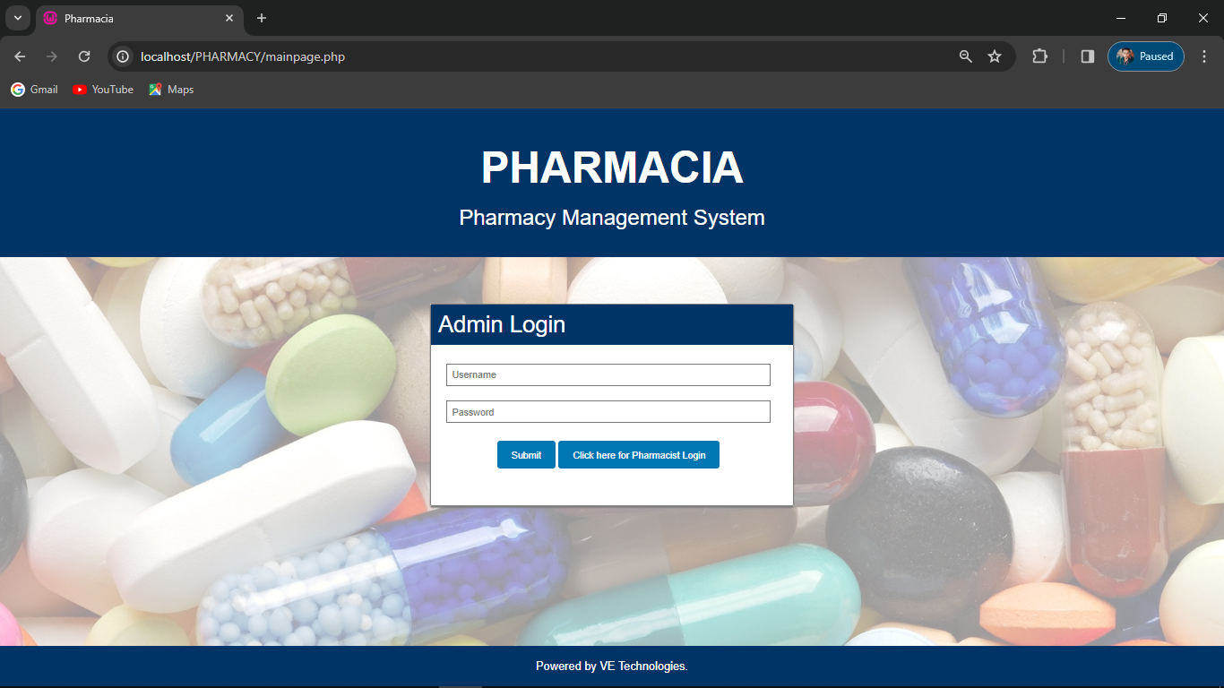

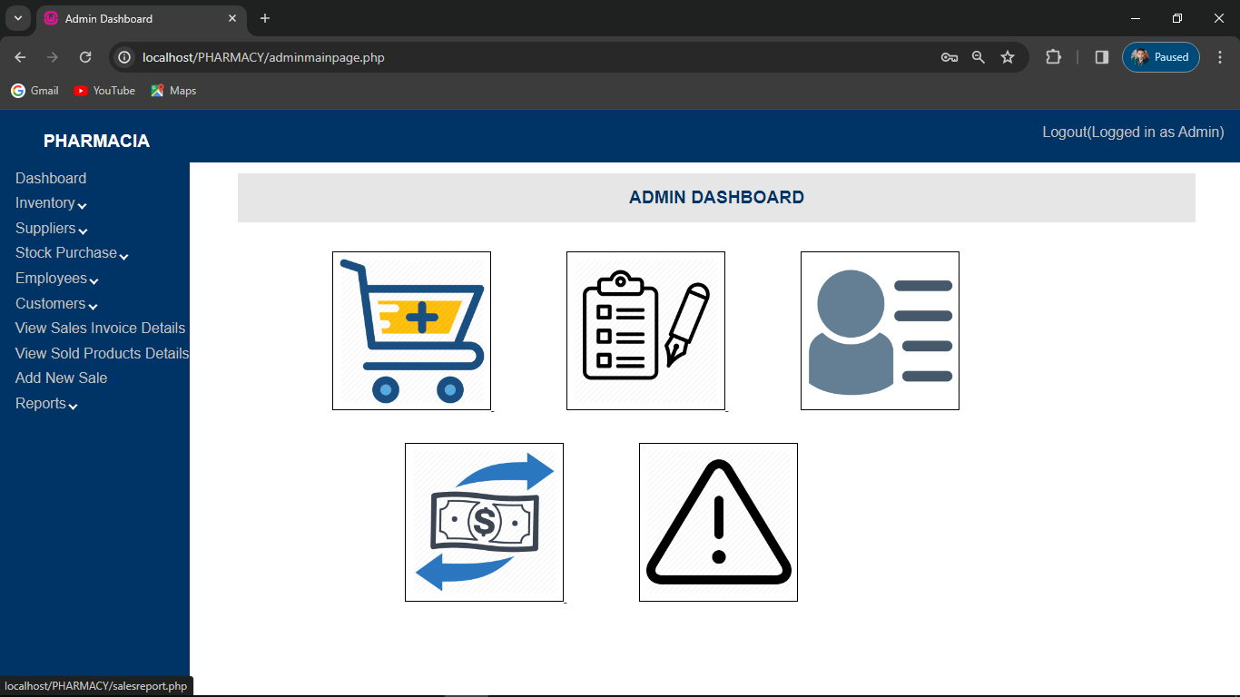

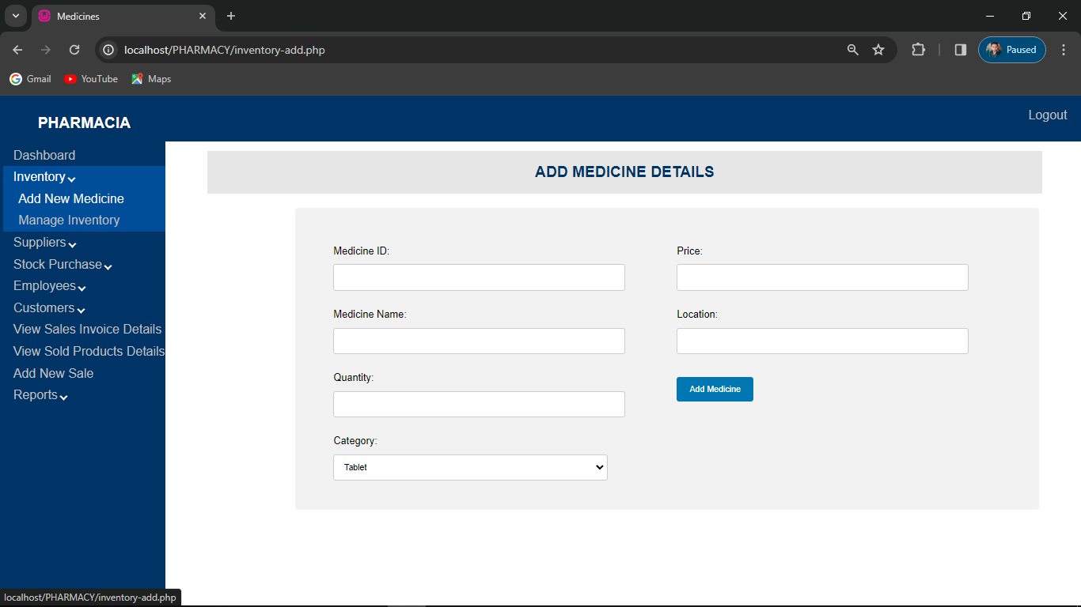

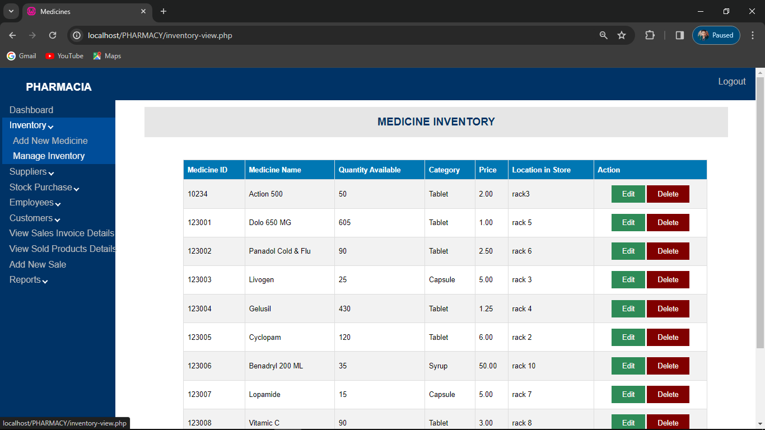

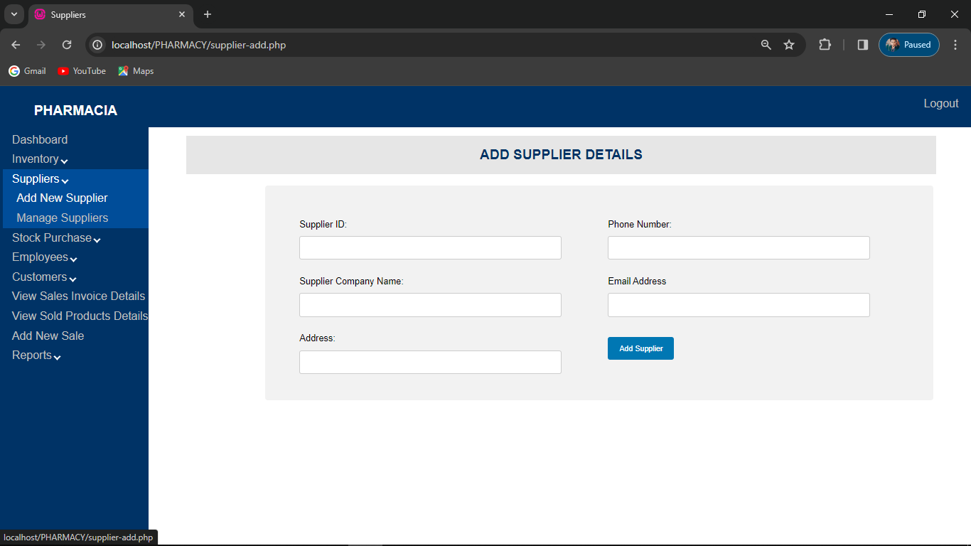

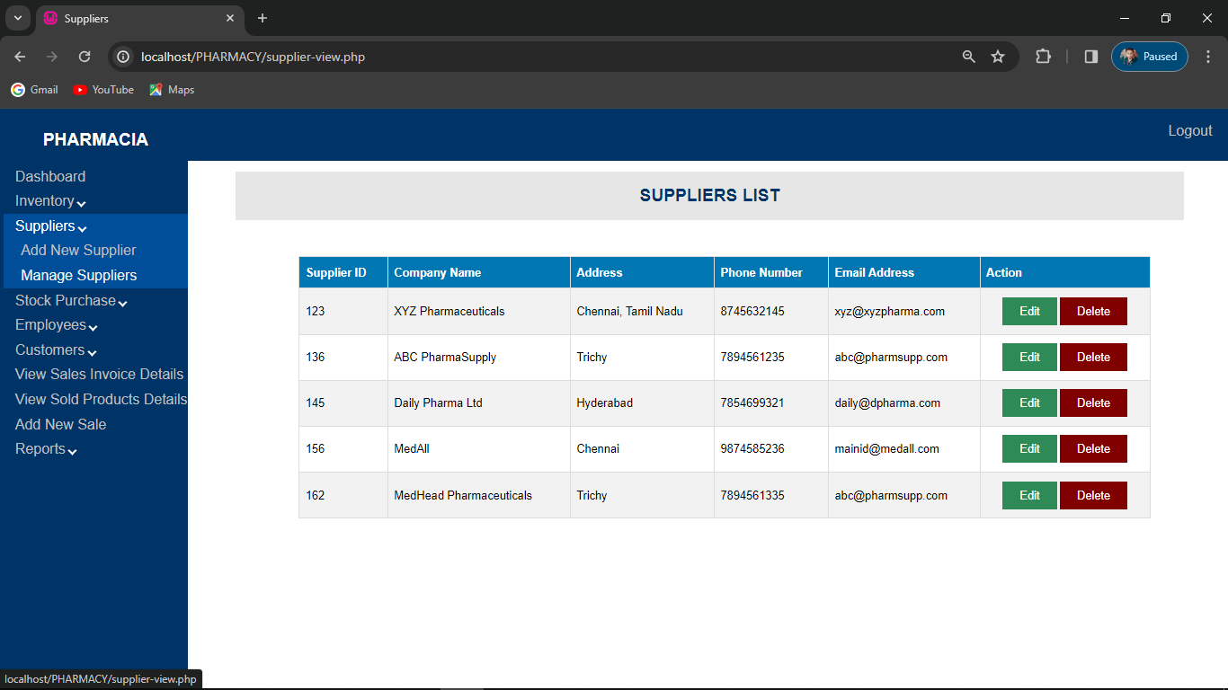

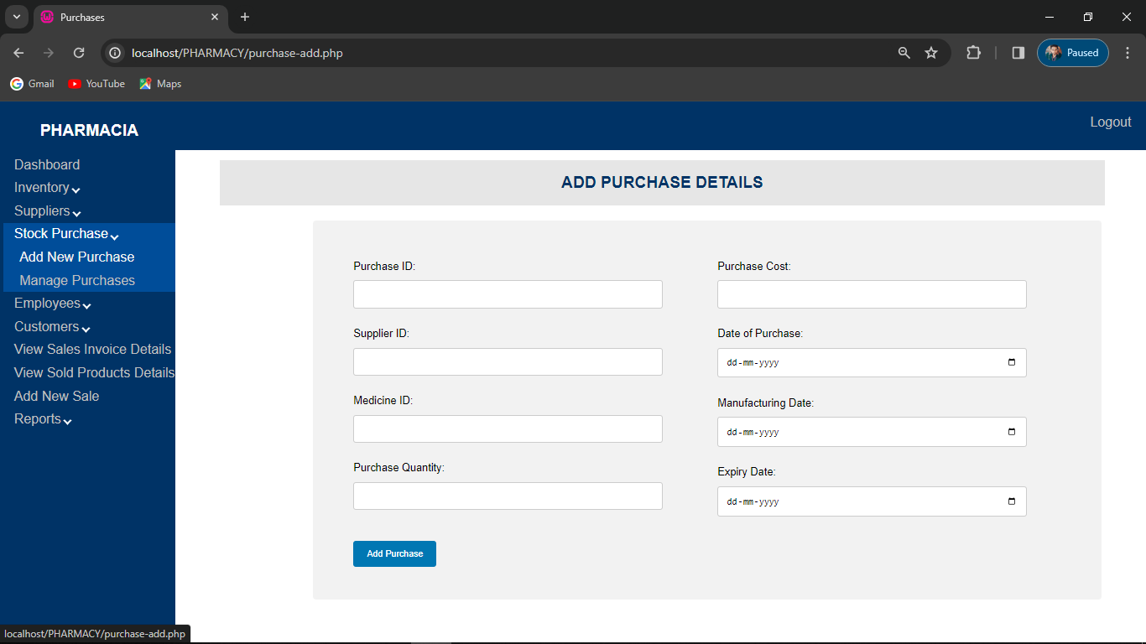

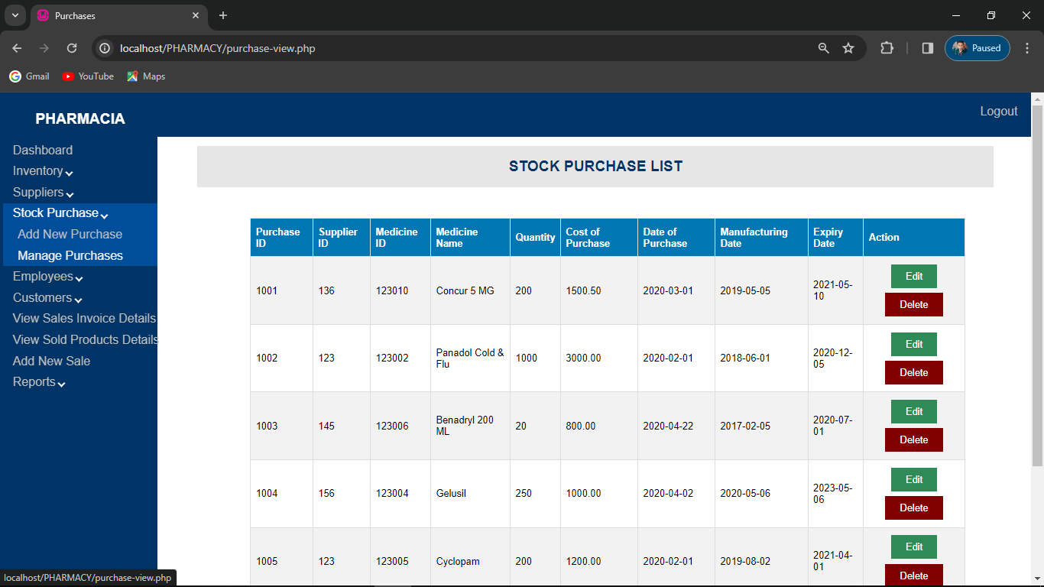

SYSTEM TESTING
9.1 TESTING
The purpose of testin g is to discover errors. Testing is the process of trying to discover every conceivable fault or weakness in a work product. It provides a way to check the functionality of components, sub-assemblies, assemblies and/or a finished product. It is also the process of exercising software with the intent of ensuring that the it meets its requirements, user expectations and does not fail in an unacceptable manner. There are various types of test that can be performed. Each type of test addresses a specific testing requirement.
Types of Tests
Unit testing.
Unit testing involves the design of test cases that validate that the internal program logic is functioning properly, and that the program inputs produce valid outputs. All decision branches and internal code flow should be validated by this test. It is the testing of individual software units of the application. It is done after the completion of an individual unit but before integration. This is a structural test, that relies on knowledge of its construction and it is invasive. Unit tests perform basic tests at the component level and test a specific business process, application, and/or system configuration. Unit tests also ensure that each unique path of a business process performs accurately to the documented specifications and contains clearly defined inputs and expected results.
Unit testing is usually conducted as part of a combined code and unit test phase of the software lifecycle, although it is not uncommon for coding and unit testing to be conducted in two distinct phases. Test strategy and approach. Field testing will be performed manually, and functional tests will be written in detail.

Test objectives
- All field entries must work properly.
- Pages must be activated from the identified link.
- The entry screen, messages and responses must not be delayed.
- Features to be tested
- Verify that the entries are of the correct formats
- No duplicate entries should be allowed.
- All links should take the user to the correct page.
Integration testing.
Integration tests are designed to test integrated software components to determine if they run as one cohesive program. Testing is event driven and is more concerned with the basic outcome of screens or fields. Integration tests demonstrate that although the components were individually satisfactory, as shown by successful unit testing, the combination of components is performing correctly and consistently. Integration testing is specifically aimed at exposing the problems that arise from the combination of these components. Software integration testing is the incremental integration testing of two or more integrated software components on a single platform to produce failures caused by interface defects.
The task of the integration test is to check that components or software applications, e.g. components in a software system or – one step up – software applications at the company level interact without error. All the test cases mentioned above passed successfully, and no defects were encountered.
Acceptance testing.
User acceptance testing is a critical phase of any project and requires significant participation by the end user. It also ensures that the system meets the functional requirements. All the test cases mentioned above passed successfully, and no defects were encountered.
Functional testing.
Functional tests provide systematic demonstrations that functions tested are available as specified by the business and technical requirements, system documentation, and user manuals. Functional testing is centered on the following items:
- Valid Input: identified classes of valid inputs must be accepted.
- Invalid Input: identified classes of invalid inputs must be rejected.
- Functions: identified functions must be exercised.
- Output: identified classes of application outputs must be exercised.
- Systems/Procedures: interfacing systems or procedures must be invoked.
The organization and preparation of functional tests is focused on requirements, key functions, or special test cases. In addition, the systematic coverage pertaining to identifying business process flows; data fields, predefined processes, and successive processes must be considered for testing. Before functional testing is complete, additional tests are identified and the effective value of current tests is determined.
System testing.
System testing ensures that the entire integrated software system meets requirements. It tests a configuration to ensure known and predictable results. An example of system testing is the configuration-oriented system integration test. System testing is based on process descriptions and flows, emphasizing pre-driven process links and integration points. There will be different layers to test and this system testing comes under a higher environment and will have restricted access to normal testers.
White box testing.
White box testing is a test in which the software tester has knowledge of the inner workings, structure and language of the software, or at least its purpose. Its purpose is used to test areas that cannot be reached from a black box level.
Black box testing.
Black box testing is a test of the software without any knowledge of the inner workings, structure or language of the module being tested. Black box tests, as with most other kinds of tests, must be written from a definitive source document, such as a specification or requirements document. It is a test in which the software under test is treated, as a black box. You cannot “see” into it. The test provides inputs and responds to outputs without considering how the software works.

CONCLUSION

10.1 CONCLUSION
As the internet becomes more widespread, new options for swiftly receiving expert advice and information from health professionals are opening up. Online pharmacies are quite useful in this situation. Patients who need support with their symptoms or discuss the potential adverse effects of medication can obtain it quickly and effectively. Online doctors and pharmacists may provide professional guidance, troubleshooting, diagnosis, and support for new and recurring drugs. Patients with chronic diseases can also benefit from the online medical service, as those who require additional medication can receive advise on dose and treatment length requirements.
On-time delivery and an easy ordering procedure Our website provides quick delivery and a straightforward purchase process, allowing you to skip the long lines. Treatment in a flash with only one click We want to make the best use of technology to promote people' health and well-being. Our medical specialists ask a series of questions to analyst the situation and then authorize the suitable patient's prescription. Additionally, a pharmacist may be reached immediately via phone, email, or chat.

BIBILOGRAPHY

REFERENCE:
- Professional ADO .NET 3.5 with LINQ and the Entity Framework, Roger Jennings, Wrox Publication.
- Professional PHP - 3rd Edition, Simen, Christien Nagal, Karil Watson, Wrox Publication
- ASP .NET 2.0 Unleashed, Stephen Walther,, SAMS Publishing, 2006.
- Beginning PHP 4.5 in C# and VB, ImarSpaanjaars, Paperback, 2012.
- Professional PHP Design Patterns , Scott Millett, Paperback, 2011.
- PHP and MySQl Projects, Shivprasad Koriala and Rajesh Pillai, Paperback, 2007.

